**Study of File System in Linux**

horizontal line

A file system is an architecture defining how files are stored and retrieved. It defines the format and logic of – if a newly created file will be saved, how will it be saved, what extra data will it be saved with, where will it be saved, and how will it be accessed from where it was saved. File systems are defined based on where they are used. There are file systems defined for operating systems, networks, databases, and other special-purpose file systems.

**The Architecture of a File System :**

A file system mainly consists of 3 layers. From top to bottom**:**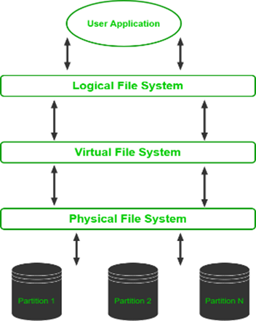

1. Logical file system interacts with the user application with the help of an API to provide open, read, close, etc. operations and passes requests to the layer below.
2. Virtual file system enables multiple instances of the physical file system to run concurrently.
3. Physical file system handles the physical aspect of the disk while managing and storing physical memory blocks being read and written

**Characteristics of a File System :**

**·** Space Management: how the data is stored on a storage device. Pertaining to the memory blocks and fragmentation practices applied in it.

· Filename: a file system may have certain restrictions to file names such as the name length, the use of special characters, and case sensitive-ness.

· Directory: the directories/folders may store files in a linear or hierarchical manner while maintaining an index table of all the files contained in that directory or subdirectory.

· Metadata: for each file stored, the file system stores various information about that file’s existence such as its data length, its access permissions, device type, modified date-time, and other attributes. This is called metadata.

· Utilities: file systems provide features for initializing, deleting, renaming, moving, copying, backup, recovery, and control access of files and folders.

· Design: due to their implementations, file systems have limitations on the amount of data they can store.

**Key components of a Linux file system include:**

Directories: Used to organize files into a hierarchical structure.

Files: Contain data, programs, or other information.

Inodes: Data structures that store metadata about files, such as permissions, ownership, timestamps, and pointers to the data blocks.

Superblock: Contains essential information about the file system, including its size, block size, and other parameters.

Blocks: The fundamental units of storage on the disk.

**Linux File Systems:**

Linux supports various file systems, each with its own features and characteristics. Some common file systems used in Linux include:

1. Ext4 (Fourth Extended File System): The default file system for many Linux distributions. It provides improvements over its predecessor (Ext3) in terms of performance and reliability.

2. Ext3 (Third Extended File System): An earlier version of Ext4, it supports journaling, which helps in faster file system recovery after an unexpected shutdown.

3. Btrfs (B-tree File System): A modern file system that supports advanced features like snapshots, subvolumes, and checksums. It's designed to address some limitations of older file systems.

4. XFS (X File System): Known for its scalability and performance on large storage systems. It's often used in enterprise environments.

5. ZFS (Z File System): Though not natively included in the Linux kernel, ZFS is a powerful file system with features like snapshotting, data integrity, and support for large storage pools. It can be used on Linux through third-party implementations.

6. FAT (File Allocation Table): Commonly used for removable storage devices and is compatible with various operating systems, including Linux.

7. NTFS (New Technology File System): Developed by Microsoft, NTFS is used for Windows operating systems. Linux has NTFS support through the ntfs-3g driver, allowing read and write access.

8. bcachefs: This is a copy-on-write file system that was first announced in 2015 with the goal of performing better than btrfs and ext4. Its features include full filesystem encryption, native compression, snapshots, and 64-bit check summing.

9. SquashFS: Developed in 2002, this file system is read-only and is used only with embedded systems where low overhead is needed.

10. Reiser4: It is an incremental model to ReiserFS. It was developed in 2004. However, it is not widely adapted or supported on many Linux distributions.

11. JFS (Journaled File System): First created by IBM in 1990, the original JFS was taken to open source to be implemented for Linux in 1999. JFS performs well under different kinds of load but is not commonly used anymore due to the release of ext4 in 2006 which gives better performance.